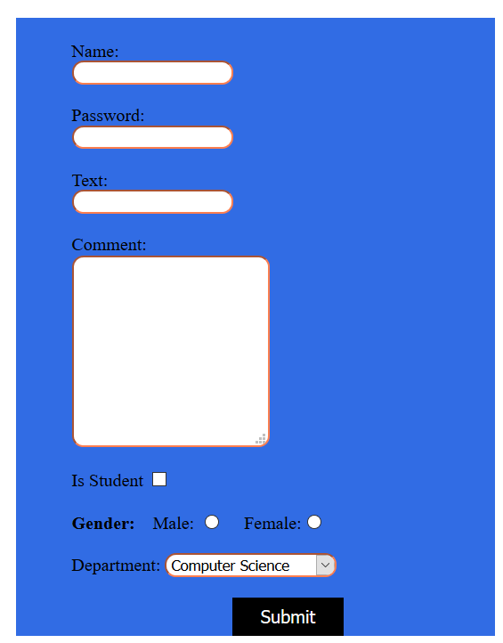

- Create the html page as shown in the figure. You have to at least add following styles as shown in the figure:
    - Make textboxes round
    - Set textbox border color.
    - Set the color of text inside textboxes.
    - Set the background and foreground color of submit button.
Note: You can add CSS either as inline, internal or external.

The following task is optional and will not be graded.
- Now apply JavaScript such that when the button is pressed, it checks whether:
    - All input textboxes have been filled.
    - The option of gender has been selected.
    - The password has the length of 6.
    - The password contains at least 1 integer and 1 alphabet.
If any of the above mentioned conditions is not satisfied, show an appropriate message.

